**INTRODUCTION TO PROGRAMMING –II**

**Muhammad Hamza Zubair**

**Tasks Summary**

**Overall it took more or less ~ 20 hours to reshape the program according to new requirements and additional elements**

**The program now takes Start and End date of the contract and tenants names and email addresses, then it generates the Excel with tenant’s name and dates (previously the excel was giving week numbers only) Finally the program checks from the list of dates and generates email alert. (For test case we can change PC date to one of those generated dates)**

The breakdown of Tasks with time spent is mentioned (on later stages the exact time was not noted down so it is aggregated time)

|  |  |
| --- | --- |
| TASK NAME | MAKING GUI |
| From | 06.12.2019 (11:00 pm) |
| To | 07.12.2019 ( ~ 04:00 am) |
| Result | Unsuccessful |

**Explanation:** First I tried to use Tkinter to make the form but the tkinter module was causing issue that I cannot store and reuse the entry box input outside the loop in a variable elsewhere. Spent all night trying to figure out how to use the entry box input but was not able to succeed in that

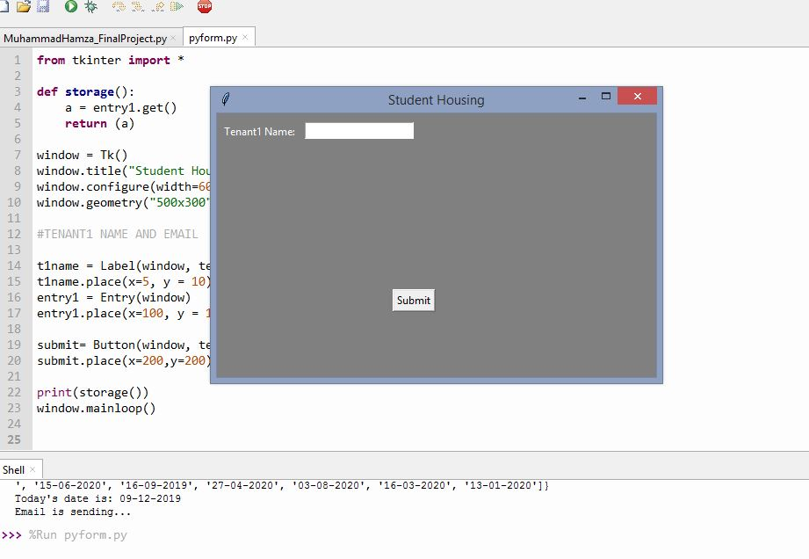

One of the answers I found was object oriented approach

<https://stackoverflow.com/questions/56426889/why-can-i-not-get-the-value-of-tkinter-variables>

<https://stackoverflow.com/questions/17203329/python-tkinter-variables-not-being-reevaluated>

Tried the Object oriented approach also but was not able to succeed

|  |  |
| --- | --- |
| TASK NAME | MAKING GUI, Weeks to Days Conversion, Date Conversion |
| From | 07.12.2019 from 11:30 am to 03:00 pm & 11:00 pm to 02:00 am |
| To | 08.12.2019 Approx 5 to 6 hours |
| Result | Successful |

**Explanation:** The new GUI was made using simple easy gui lib, also 2 new functions were created which use the weeks numbers to convert it into days(from starting date) and another function is used to convert those days to dates.

|  |  |
| --- | --- |
| TASK NAME | Email Notification Alert |
| From | 11.12.2019 |
| To | 11.12.2019 approx 5 hours |
| Result | Successful |

**Explanation:** this was second hectic task after the tkinter GUI creation (global variable issues etc). this taskw as achieved using SMPTP library and one for sending email and second function calls for notification.

Lastly 10 to 15 mins to write this documents ☺